Homework for Chapter 8: Causal Paths

1. Assuming that a path has no colliders on it, what is the difference between a path being Open and Closed? **It is literally about the direction of the arrows from variables. Like for example X🡪 C🡨 D is a closed path. THEN an open would be like X🡪 A 🡪 Y**
2. Consider the below generic causal diagram.  
   Diagram, shape

   Description automatically generated
   1. List every path from X to Y.
      1. X 🡪 A 🡪 Y
      2. X🡪 C 🡨 D 🡪 Y
      3. X 🡨 B 🡨 D 🡪 Y
      4. X 🡨 B 🡪 Y
   2. Which of the paths are front-door paths?
      1. Just the one X 🡪 A 🡪 Y
   3. Which of the paths are open back-door paths?
      1. X🡪 C 🡨 D 🡪 Y
      2. X 🡨 B 🡨 D 🡪 Y
      3. X 🡨 B 🡪 Y
      4. **Note to self: closed paths are those with variables that do not have variation.**
   4. What variables must be controlled for in order to identify the effect of X on Y? (only list what *must* be controlled for, not anything that additionally *could* be controlled for).
      1. **B must be controlled for (conditioned on) and I am thinking D but am not entirely sure, I think it would be best especially bc C is a collider.**
3. Consider the research question: Does having higher income cause better health?
   1. Draw a causal diagram depicting the data generating process for this relationship with 5-10 variables on it.
   2. Identify the Front Door paths.
      1. These are the paths in green
   3. Identify the Back Door paths.
      1. These are the paths in red
   4. Identify the paths that represent direct effects.
      1. ? direct effects of what
   5. Identify the Good Paths and the Bad Paths.
      1. Basically all front door are good paths and bad paths are backdoors
      2. 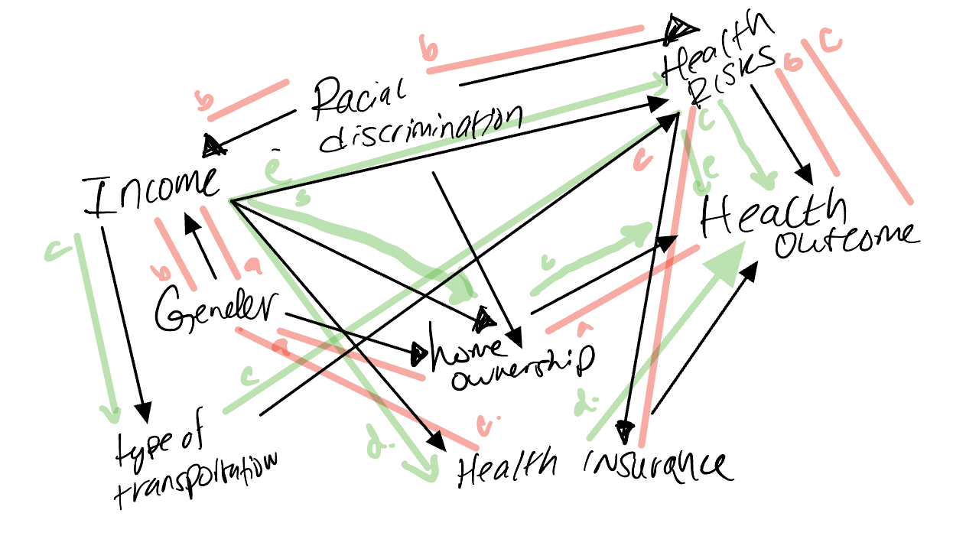
4. Which of the following describes a causal path where all the arrows point away from the treatment?
   1. Open Path
   2. Closed Path
   3. **Front Door Path**
   4. Back Door Path
5. Consider the figure below, which depicts the relationship between teaching quality, number of publications (e.g., articles, books), and popularity among scholars and students in a population of professors.  
   Line chart

   Description automatically generated
   1. What type of variable is Popularity in one path on this diagram? ***Collider***
   2. Discuss what would happen if you controlled for Popularity***. It would open the path between teaching quality and number of publications, and it would be cyclical***
6. Consider the figure below, which depicts the relationship between a pandemic-related lockdown and an economic recession. The research question of interest is: Does a pandemic-related lockdown cause recession?   
   A picture containing text, antenna, line

   Description automatically generated
   1. Write down all the paths in the diagram from Lockdown to Recession. To make our lives simpler (there are a lot of paths in this diagram), ignore any path that goes through Stimulus.
      1. **Lockdown🡨 prior economy 🡪 recession**
      2. **Lockdown 🡨prior economy 🡪 unemployment 🡪 recession**
      3. **Lockdown 🡪 Recession**
      4. **Lockdown 🡪 Unemployment 🡪 Recession**
      5. **Lockdown 🡪 Unemployment 🡨 Prior economy 🡪 Recession**
   2. List all of the paths that are Front Door Paths.
   3. What would happen if we controlled for unemployment?
      1. ***Conditioning on unemployment would be a nightmare as a collider variable because then the pathways where all variables other than the outcome variable now have open paths introduced.***
   4. Is it possible to measure each of the variables adequately?
      1. ***I mean no, I think Lockdown would be difficult to measure. Maybe if you were able to acquire all local policies, but doubtful.***
   5. Can you think of any variables and paths not depicted in the diagram that may be relevant to identify the answer to the research question? List at least one and no more than three.
      1. **Quarantining from contagion**
      2. **Stock market bailouts**
7. Consider the question: Does obtaining a higher education improve income? Think of a couple of examples of Bad Paths in a causal diagram depicting the data generating process for this research question.
   1. **Okay bad paths could include higher education 🡨 gender 🡪 occupation 🡪 income, and another could be priordebt 🡪 higher education 🡨 debt after education 🡪 income, another could involve racial discrimination, and then also if we were to measure urbanicity.**